20- DNA TECHNOLOGY
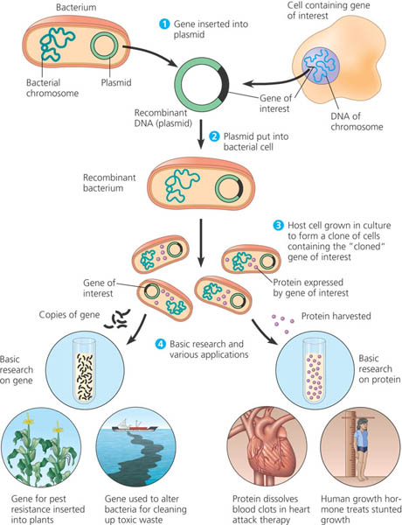
GENETIC ENGINEERING:
manipulating genes and genomes
RECOMBINANT DNA.
Combining DNA from different organisms
APPLICATIONS OF DNA TECHNOLOGY
• DIAGNOSIS OF DISEASE
Virus detection;
ID genetic carriers/disorders
• GENE THERAPY
ID mutant genes; purify replacements
• PHARMACEUTICAL PRODUCTION
Bacterial production of insulin,
Human Growth hormone
• FORENSICS/PATERNITY
Crime scene analysis
Who’s the daddy?
• GENETICALLY MODIFIED ORGANISMS
“Golden” rice-gene for Vitamin A added
Bt-corn -resists insect pests
“frost resistant” strawberries
toxin/pollution “eating” bacteria
• ENDANGERED SPECIES ZOO
cloning extinct/endangered species

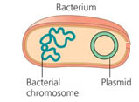
PLASMIDS = small self replicating DNA loops
• Can carry genes for ANTIBIOTIC RESISTANCE (used as genetic markers
•Used as VECTORS to carry recombinant DNA
•Can be cut with RESTRICTION ENZYMES
•Used to incorporate foreign DNA into bacteria
•Bacteria then reproduce, copying the inserted gene along with the plasmid

Ways to make bacteria able to “take up” foreign DNA = make them “COMPETENT”
1) ELECTROPORATION- zap with electricity
2) Use calcium chloride and “heat shock” to change their cell walls (We did this in LAB 8)
- makes cells better able to pick up plasmids/DNA
- rapidly growing cells are made competent more easily
pGLO
ori
bla
GFP
araC
GFP (Green Fluorescent Protein)
•Originally discovered in jellyfish
• Linked to plasmids carrying recombinant genes
•Used as a genetic tool to identify presence of recombinant genes

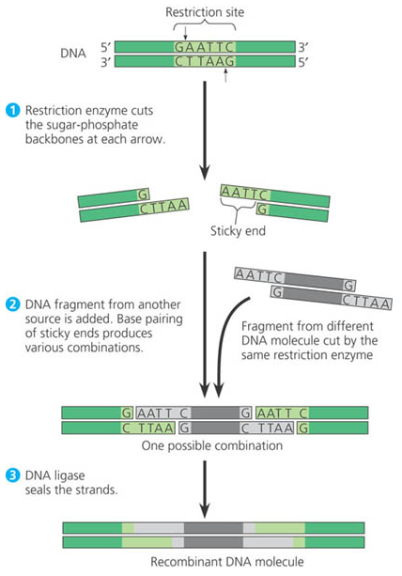
RESTRICTION ENZYMES (RESTRICTION ENDONUCLEASES)
• Occur naturally in bacteria
• Function = protect bacteria from invasion by foreign DNA
• Each enzyme recognizes different specific code sequences
~often palindromes
• Cut DNA into short segments with staggered “sticky ends”
• Named for bacteria they come from: EX: EcoR1; HindIII; BamH1
• DNA ligase used to join DNA pieces cut with same enzymes
• Used to combine DNA from different organisms (recombinant DNA)
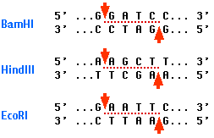

REVERSE TRANSCRIPTASE
• Enzyme from RETROVIRUSES (RNA containing viruses)
• info flows backwards RNA → DNA
• Can be used to put eukaryotic genes into bacteria
• Bacteria don’t process DNA so eukaryotic genes with introns can’t be used directly
• Reverse transcriptase enzymes can take n “edited” message and change it into a gene

GENE CLONING in BACTERIA
•process used to produce multiple copies of specific segments of DNA
• Isolate bacterial plasmid and foreign DNA
•Treating with same restriction enzyme produces same “sticky ends”
• Mix DNA
•DNA ligase joins “sticky ends”
• recombinant plasmid into taken up by bacteria (transformation)
• bacteria reproduce resulting in multiple copies of the inserted gene
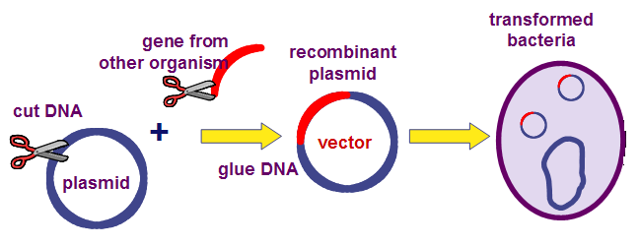

IDENTIFYING BACTERIA WITH RECOMBINANT PLASMIDS
~Ability to grow in presence of antibiotics
~ Presence of GFP (glow under UV light)
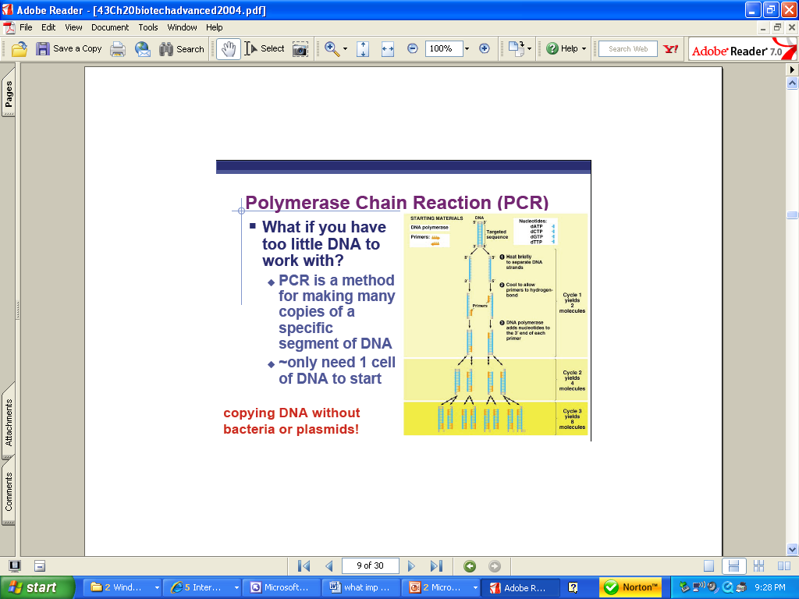
GENE CLONING WITH
POLYMERASE CHAIN REACTION (PCR)
Used to AMPLIFY DNA
Makes billions of copies of even small quantities of DNA
NEED:
target DNA, primers, nucleotides, & DNA Polymerase

Heat (94° C )- DNA helix unwinds/separates *
Cool (54° C) -
DNA hybridizes with primers and builds chain
Both strands of DNA are copied; then copied strands are used as templates in next round
Heating/cooling process is repeated many times to get many copies
PROBLEM*
HEAT destroys DNA Polymerase
SOLUTION:
Use Taq POLYMERASE
from hot springs archeabacteria
(Thermus aquaticus)
~THERMOSTABILE-withstands 90° heat needed for strand separation

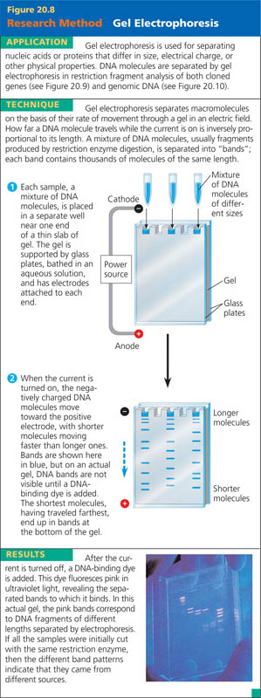
RFLP’s (RESTRICTION FRAGMENT LENGTH POLYMORPHISM) ANALYSIS
- inherited differences found among the individuals in a population
- differences in DNA code result in different restriction sites in DNA
- produces fragments of different lengths
= restriction fragment length polymorphisms (RFLP's)
- treat DNA with restriction enzymes
- use gel electrophoresis to separate the restriction fragments
AGAROSE GEL ELECTROPHORESIS = “swimming through JELLO”
*** CAN BE USED TO SEPARATE ANY MOLECULE WITH A CHARGE
~ not just for DNA (Ex: proteins)
•DNA is negatively charged (due to phosphates) so moves in electric field
•Used to separate DNA fragments after cut with restriction enzymes
•Separates by size and electric charge
•Can identify DNA molecules by banding patterns
•Can isolate and purify genes
•DNA molecules can be identified by specific band patterns
~ separated by size and electric charge
~ DNA has + charge due to phosphates in backbone
~ Smaller fragments move farther
~ More voltage-move faster

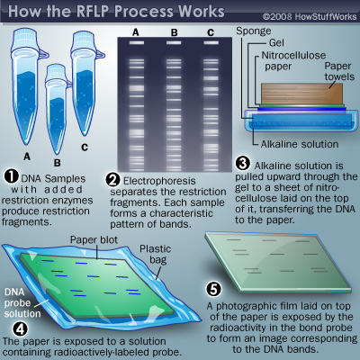
DNA DETECTION
• ETHIDIUM BROMIDE-
Glows under UV light
but highly carcinogenic
• METHYLENE BLUE DYE
-see as blue bands
• SOUTHERN BLOT
-uses radioactively labeled
probes to ID specific DNA
segments
-expose Xray film

.

