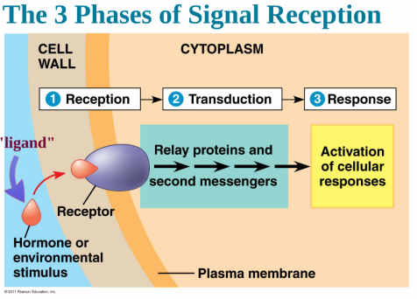
CELL COMMUNICATION
RECEPTION- LIGAND (signal molecule) binds to specific RECEPTOR on outside of cell.
TRANSDUCTION- Signal is converted to another form inside cell that produces a specific cellular response
RESPONSE- specific cell response is produced inside cell
LIGANDS CAN BE:
• HYDROPHOBIC or SMALL- EX: TESTOSTERONE and CORTISOL
Enter cell and bind to INTRACELLULAR receptors in cytoplasm or nucleus
• HYDOPHILIC- water-soluble ligands EX: INSULIN and EPINEPHRINE (ADRENALIN)
Stay outside cell; Bind to receptors in PLASMA MEMBRANE
CONFORMATIONAL CHANGE in receptor = initial transduction of signal
Binding of ligand to EXTERNAL receptors releases INTERNAL signaling molecules
CELL SIGNALING leads to REGULATION OF TRANSCRIPTION or CYTOPLASMIC ACTIVITIES
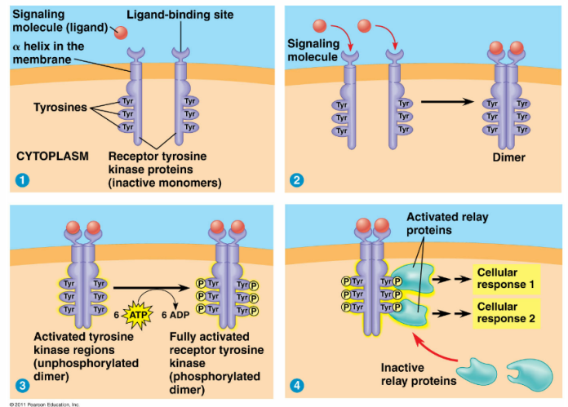
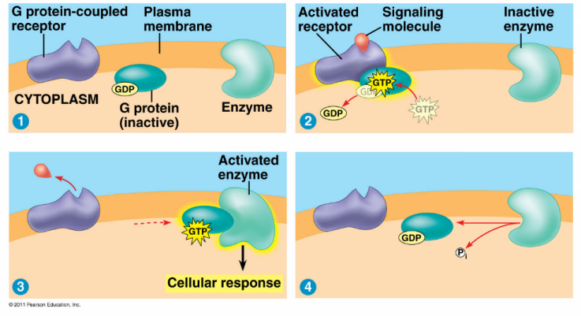
G-PROTEIN RECEPTOR-
• Ligand binds receptor attached to G protein
• Conformation change causes inactive G=protein to
attach
• GTP displaces GDP and activates G-protein
• Active G-protein activates another enzyme
TYROSINE KINASE RECEPTOR-
KINASE- Protein that “phosphorylates”
(adds a phosphate to) another molecule
TYROSINE KINASES:
• Attachment of ligand to receptor forms dimers
• Active dimers transfer phosphates to other
proteins which produce a response
• Remain ACTIVE as long as LIGAND is attached
LIGAND-GATED ION CHANNELS-
• LIGANDS open passageways for specific ions
• Influx of ions causes cellular response
SIGNAL TRANSDUCTION PATHWAYS
• often involve a PHOSPHORYLATION CASCADE
• Each step PROTEIN KINASES activate other proteins
• Allows for AMPLIFICATION of signal
( produces large response)

SECOND MESSENGERS
-Small, non-protein water soluble molecules or ions
EX: Ca⁺⁺ ions and cyclic AMP
• once activated, 2nd messengers can initiate a phosphorylation cascade
SAME LIGAND CAN PRODUCE DIFFERENT RESULTS IN DIFFERENT TISSUES VIA DIFFERENT INTRACELLULAR PROTEINS

EXAMPLES OF CELL COMMUNICATION (There are many, many more)
QUORUM SENSING in bacteria: communication among microbes that triggers group response when population reaches certain density
APOPTOSIS (programmed cell death) integrates multiple cell signaling pathways
• Signals activate cascase of “suicide” proteins in cell
• Important part of embryonic development in vertebrates, essential for nervous system formation,
operation of immune system, morphogenesis of hands/feet & loss of tails in humans

