FREDERICK GRIFFITH – 1928
2 strains of pneumonia bacteria
S strain with smooth capsule coating is virulent → kills mice (and people)
R strain without coating → non-lethal
Heat killed S strain → non-lethal
Heat killed S + live R strain → lethal
Something passed from the dead S bacteria to live R strain causing a genetic change which was passed on to offspring (= TRANSFORMATION)
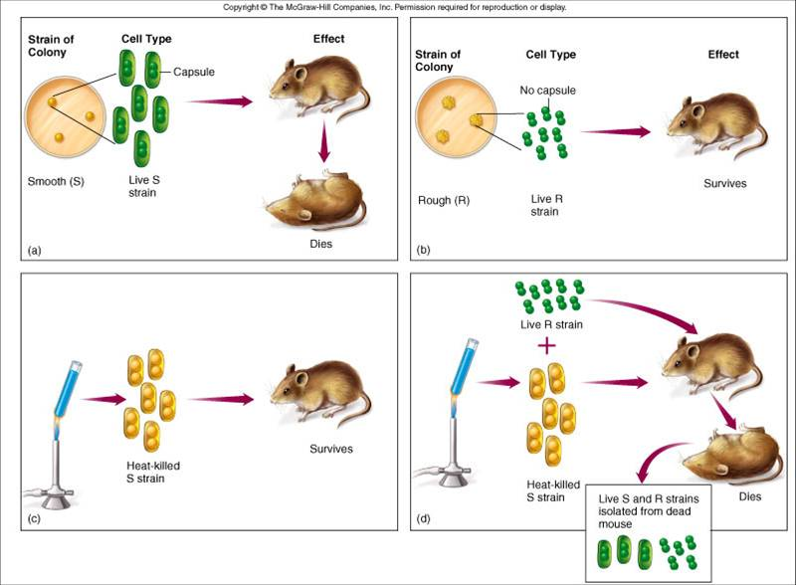

SO WHAT? Set stage for search for the identity of the transforming molecule

WHICH IS THE GENETIC MATERIAL- Protein or DNA ?

OSWALD AVERY, MACLYN M^{c}CARTY, & COLIN MACLEOD- 1943

Repeated Griffith’s experiment but. . .
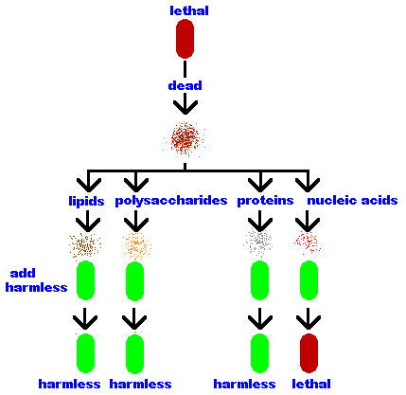
after heat killing S bacteria, enzymes were added to digest various molecules before injecting the mice

If DNA was destroyed, NO transformation happened

If other kinds of molecules were destroyed, transforming molecule still made R bacteria lethal

SO WHAT? showed the transforming substance (ie. molecule that carried genetic info) was DNA!

WHICH IS THE GENETIC MATERIAL- Protein or DNA?

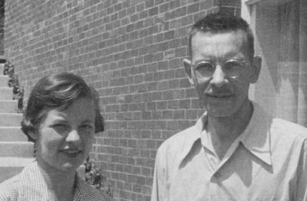
HERSHEY CHASE BLENDER EXPERIMENT- 1952
Bacteriophages (viruses that infect bacteria) have a protein coat and DNA inside

The BLENDER EXPERIMENT
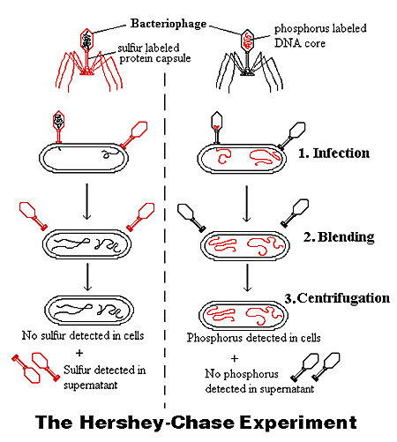

Martha Chase and Alfred Hershey
1. T2 phages labeled with radioactive ³⁵S (labels protein coat)
2. T2 phages labeled with radioactive ³²P (labels DNA)
3. Infect Escherichia coli (E. coli ) bacteria.
4. Spin in a blender to knock off what’s on outside of cell
5. Centrifuge to separate cells from liquid

Found radioactive ³²P label (DNA) in cells and radioactive ³⁵S (protein) in liquid

SO WHAT?
PROVED DNA NOT PROTEIN was what got into cell to pass on phage genetic info

* * * * * * * * * * * * * * * * * * * *
ROSALIND FRANKLIN and MAURICE WILKINS
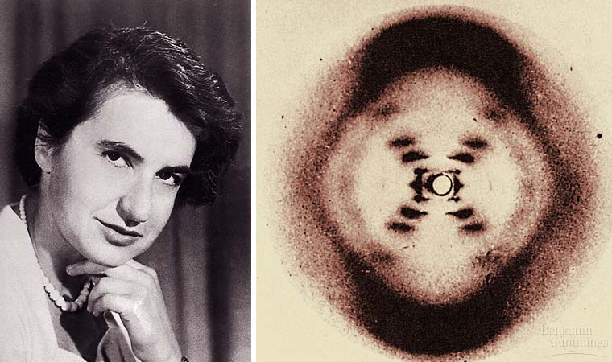
Analyzed DNA with X-ray crystallography to try and determine structure of DNA She died young from cancer;

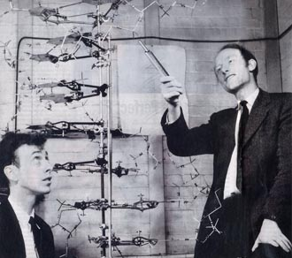

JAMES WATSON and FRANCIS CRICK
Used Rosalind Franklin’s X-ray crystallography images (PHOTO 51)
to come up with a model for the structure of DNA -1953

1962-Watson, Crick, & Wilkins received the Nobel prize for structure of DNA.
(They don’t give Nobel prizes to dead people.)
* * * * * * * * * * * * * * *
ERWIN CHARGAFF - 1947
Analyzed base composition of DNA from a number of different organisms

CHARGAFF’s RULES: Concentration of A = T and G = C
* * * * * * * * * * * * * * *
THREE POSSIBILE MODELS FOR REPLICATION

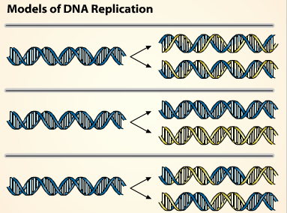

SEMI-CONSERVATIVE

CONSERVATIVE

DISPERSIVE

EXPERIMENT: Matthew Meselson and Franklin Stahl- 1958
- Grow E. coli bacteria with radioactive ¹⁵N (its heavier than ¹⁴N) so bacteria incorporate heavy N into their DNA
- Then grow in media with only ¹⁴N
- Centrifuge DNA at different times to separate by size. (The more ¹⁵N it has the heavier it is)
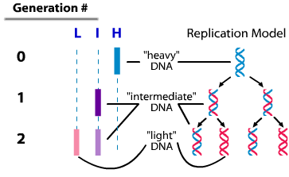
- Pattern shows which model is correct
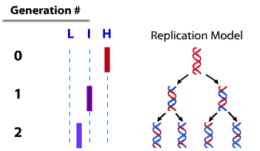
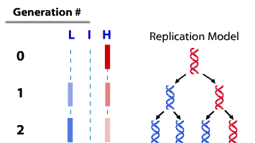

SO WHAT?: MESELSON & STAHL EXPERIMENT proved correct replication model was SEMI-CONSERVATIVE

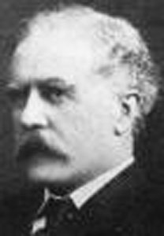
ARCHIBALD GARROD – 1902
- 1st to suggest genes dictate phenotypes through enzymes that catalyze specific chemical reactions
- Postulated that the symptoms of an inherited disease are due to inability to make a specific enzyme
- Coined term “inborn errors of metabolism” to describe such diseases
- ALCAPTONURIA- “black urine” disease- defect in enzyme that breaks down amino acid tyrosine

* * * * * * * * * * * * * * * * * * * *
GEORGE BEADLE and EDWARD TATUM
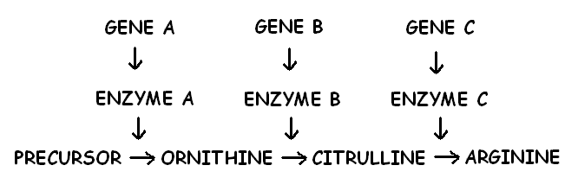
- Demonstrated relationship between genes and enzymes
- Created mutants in mold Neurospora crassa using Xrays that couldn’t grow on minimal media
- Worked out biochemical pathway for arginine production from mutant growth patterns by showing mutants could grow if product they could NOT make was added to growth media
SO WHAT? Their “ONE GENE-ONE ENZYME” hypothesis became: “ONE GENE-ONE POLYPEPTIDE”
(NOW: It’s really ONE GENE- one polypeptide OR an RNA molecule)

* * * * * * * * * * * * * * * * * * * *
MARSHALL NIRENBERG et al. – 1961
- Determined 1st codon-amino acid match (UUU-Phenylalanine)
- Made artificial poly-U RNA (UUUUUU), added to test tube of ribosomes and nucleotides, and it made a long phenylalanine chain

